4.33: a) The resultant must have no y-component, and so the child must push with a force with y-component For the child to exert the smallest possible force, that force will have no x-component, so the smallest possible force has magnitude 16.6 N and is at an angle of 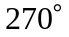, or 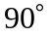 clockwise from the
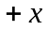-direction.

b).

